ARAÇ :

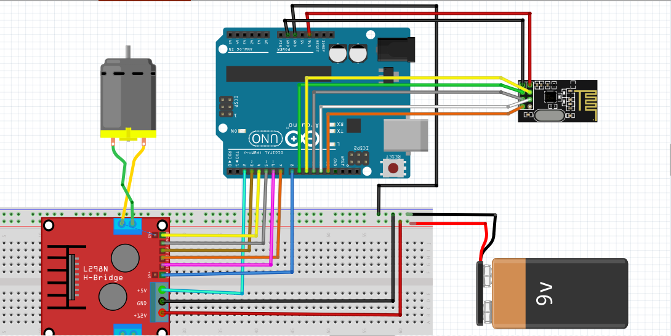

KOD:

#include <SPI.h>

#include "RF24.h"

const int enbA = 8;

const int enbB = 4;

const int IN1 = 6;

const int IN2 = 7;

const int IN3 = 3;

const int IN4 = 5;

int data[2];

RF24 radio(9,10);

const uint64_t pipe = 0xE8E8F0F0E1LL;

void setup(){

pinMode(enbA, OUTPUT);

pinMode(enbB, OUTPUT);

pinMode(IN1, OUTPUT);

pinMode(IN2, OUTPUT);

pinMode(IN3, OUTPUT);

pinMode(IN4, OUTPUT);

Serial.begin(9600);

radio.begin();

radio.openReadingPipe(1, pipe);

radio.startListening();

}

void loop(){

if (radio.available()){

radio.read(data, sizeof(data));

if(data[0] > 150){

analogWrite(enbA, data[0]);

analogWrite(enbB, data[0]);

digitalWrite(IN1, LOW);

digitalWrite(IN2, HIGH);

digitalWrite(IN3, LOW);

digitalWrite(IN4, HIGH);

}

if(data[0] < 100){

analogWrite(enbA, data[0]);

analogWrite(enbB, data[0]);

digitalWrite(IN1, HIGH);

digitalWrite(IN2, LOW);

digitalWrite(IN3, HIGH);

digitalWrite(IN4, LOW);

}

if(data[1] > 150){

analogWrite(enbA, data[1]);

analogWrite(enbB, data[1]);

digitalWrite(IN1, HIGH);

digitalWrite(IN2, LOW);

digitalWrite(IN3, LOW);

digitalWrite(IN4, HIGH);

}

if(data[1] < 100){

analogWrite(enbA, data[1]);

analogWrite(enbB, data[1]);

digitalWrite(IN1, LOW);

digitalWrite(IN2, HIGH);

digitalWrite(IN3, HIGH);

digitalWrite(IN4, LOW);

}

if(data[0] > 100 && data[0] < 150 && data[1] > 100 && data[1] < 150){

analogWrite(enbA, 0);

analogWrite(enbB, 0);

}

}

}

EL KONTROLCÜ:

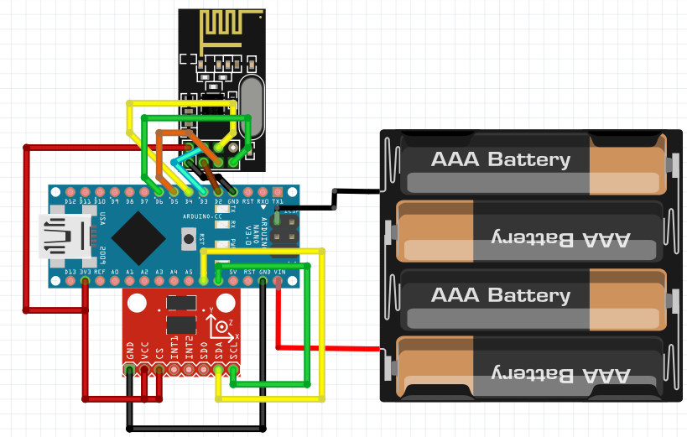

KOD:

#include <SPI.h>

#include “RF24.h”

#include “Wire.h”

#include “I2Cdev.h”

#include “MPU6050.h”

MPU6050 mpu;

int16_t ax, ay, az;

int16_t gx, gy, gz;

int data[2];

RF24 radio(9,10);

const uint64_t pipe = 0xE8E8F0F0E1LL;

void setup(void){

Serial.begin(9600);

Wire.begin();

mpu.initialize();

radio.begin();

radio.openWritingPipe(pipe);

}

void loop(void){

mpu.getMotion6(&ax, &ay, &az, &gx, &gy, &gz);

data[0] = map(ax, -17000, 17000, 0, 250 );

data[1] = map(ay, -17000, 17000, 0, 250);

radio.write(data, sizeof(data));

}

KÜTÜPHANELER:

